DG [Name]
Unit [Name]

Project Work Plan
<Project Name>
Date: <Date>
Doc. Version: <Version>
Template Version: 3.0.1

This template is based on PM² v3.0
For the latest version of this template please visit the PM² Wiki

Document Control Information

Settings | Value
Document Title: | Project Work Plan
Project Title: | <Project Name>
Document Author: | <Document Author>
Project Owner: | <Project Owner (PO)>
Project Manager: | <Project Manager (PM)>
Doc. Version: | <Version>
Sensitivity: | <Public, Limited, High>
Date: | <Date>

Document Approver(s) and Reviewer(s):
NOTE: All Approvers are required. Records of each approver must be maintained. All Reviewers in the list are considered required unless explicitly listed as Optional.
Name | Role | Action | Date
 |  | <Approve / Review>

Document history:
The Document Author is authorized to make the following types of changes to the document without requiring that the document be re-approved:
- Editorial, formatting, and spelling
- Clarification

To request a change to this document, contact the Document Author or Owner.
Changes to this document are summarized in the following table in reverse chronological order (latest version first).
Revision | Date | Created by | Short Description of Changes

Configuration Management: Document Location
The latest version of this controlled document is stored in <location>.

<These notes should be deleted in the final version :>

Notes for Templates:
- Text in <orange>: has to be defined.
- Text in <blue>: guidelines and how to use the Template. Should be deleted in the final version.
- Text in green: can be customised. Should be recolored to black in the final version.

TABLE OF CONTENTS
1. Introduction 3
2. Work Breakdown 3
3. Effort & Cost Estimates 5
3.1. Estimates 6
3.2. Resource needs 7
4. Project Schedule 9
5. Related PM² Plans 10
Appendix 1: References and Related Documents 11

Introduction
The Project Work Plan documents all project activities needed to achieve the project goals along with their detailed effort/cost estimates, their schedule and resulting project duration and resource requirements. The Project Work Plan will be used as the basis to monitor the progress and control the project.
This Project Work Plan includes the estimated effort/cost and schedule for ALL project activities, including the ones identified and described in other project plans (i.e. Transition Plan, Business Implementation Plan) as well as project management activities related to Risk Management, Quality Management (e.g. scheduled project evaluation or audits) and Deliverables Acceptance.
Note that this document will always contain the latest baselined plan. References to previous versions of this document (for the purposes of tracing changes) along with the relevant status reports are found in the Appendix 1: References And Related Documents.
<Note that this document should be formally updated and released whenever there is a change to the baselined work plan, which ideally should be harmonized with the predetermined controlling period.>

Work Breakdown
This section presents the breakdown of the project into smaller and more manageable components such as deliverables, work packages, activities, and tasks. Each lower level of the representation offers a finer level of detail of the deliverables and work that all together define the project output(s) and the work involved to produce them.
<Note that you are not obliged to use any of the templates provided in this document. You can use your own templates, or software application (e.g. MS Project) to create and document your Work Plan breakdown. If you prefer, you can copy&paste your baselined plan into this document, or simply reference the relevant file (offer a link or a folder/file location).>
Each component of the work breakdown has a unique type (e.g. Deliverable, Activity, Task, Work Package), a name and ID. The ID convention followed is described below:
- The Project itself is the first level of the breakdown and its component ID is 1.0.
- The second level (be it deliverables or groupings of work) is codified with an increase of the second digit and is therefore represented with 1.1 for the first component, 1.2 for the second etc.
- Similarly, the third level is codified with an increase in the third digit (i.e. 1.1.1, 1.1.2, 1.2.1, 1.2.2. etc.).
Work Breakdown Structure
<Choose one of the approaches for the representation of the work breakdown. For instance the work breakdown can be based on any of the following approaches: Deliverables-based breakdown, Work-based breakdown, or Phase-based breakdown.>
<Tips:
- Make sure that all deliverables have been considered.
- Consider review, testing and training tasks.
- Consider transition and operational transfer activities.
- Consider business implementation activities.
- Also Include important Project Management related activities.>

Template for Work Breakdown
1.0 |  | Project
1.1 |  | Deliverable
1.1.1 |  |  | Activity
1.1.1.1 |  |  |  | Task
1.1.1.2 |  |  |  | Task
1.1.2 |  |  | Activity
1.1.3 |  |  | Activity
1.2 |  | Deliverable
1.2.1 |  |  | Activity
1.2.2 |  |  | Activity
1.2.3 |  |  | Activity
1.2.4 |  |  | Activity
1.3 |  | Deliverable
1.3.1 |  |  | Activity
1.3.2 |  |  | Activity
1.3.2.1 |  |  |  | Task
1.3.2.2 |  |  |  | Task
1.3.3 |  |  | Activity
<Template for Work Breakdown>

Template for Work Breakdown Component Description
1.1 Deliverable
< Provide a description of this Deliverable. The level of detail provided here should accommodate the purpose of this document , which is to document planning, and facilitate execution and controlling of the project>.
1.1.1 Activity
< Provide a description of this Activity. The level of detail provided here should accommodate the purpose of this document , which is to document planning, and facilitate execution and controlling of the project>.
1.1.1.1 Task
< Provide a description of this Task. The level of detail provided here should accommodate the purpose of this document , which is to document planning, and facilitate execution and controlling of the project>.
1.1.1.2 Task
….
<Template for Work Breakdown Component Description>

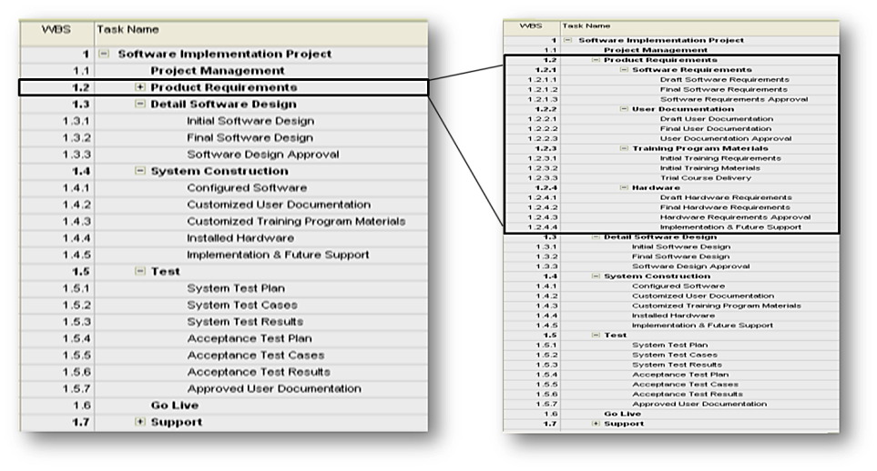
<Example: Work Breakdown (list format).>
<Don't forget to delete this example from your final Work Plan>
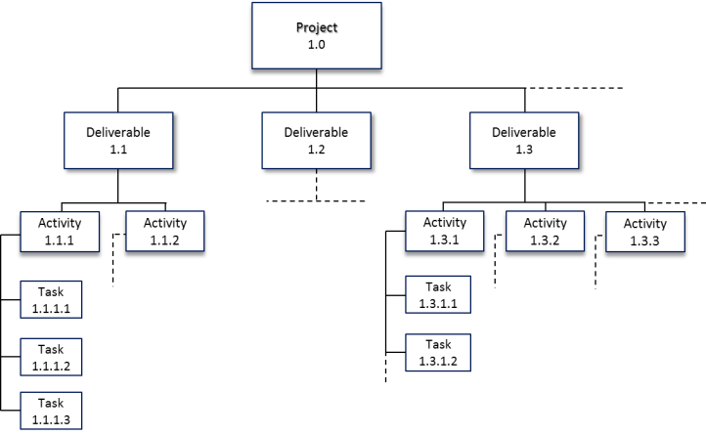
<Example: Work Breakdown (tree format)>
<Don't forget to delete this example from your final Work Plan>
<For your work breakdown, you can use any representation that accommodates your project's needs. You can also provide the work breakdown in either a list format or in tree format (or in both).>
<We remind you that you are not obliged to use the templates provided here as examples. You can use your own templates, or software application (e.g. MS Project) to create and document your work breakdown. Then you can copy&paste the baseline plan into this document, or simply reference the relevant file (offer a link or a folder/file location).>

Effort & Cost Estimates
This section documents the reasoning and final effort and cost estimates of all project activities. The work breakdown of Section 2 is the input for the estimation.
< Choose one or more of the different approaches to estimating: expert advice, historical information, similarity to other tasks, etc.
For more accurate estimates, make sure you involve task owners or other experts for each impact area (usually members of the Project Core Team (PCT)). Include some contingencies based on the involved uncertainties or risks.
Resources of different types can be necessary to accomplish certain tasks or deliverables: people, software, hardware, equipment, buildings & facilities, supplies, materials, etc.
In order to calculate the Total Cost, you'll need to know the cost per unit for each resource.>

Estimates
Work Breakdown |  |  |  |  | Predecessors /  Dependencies | Resource | Quantity  (e.g. Workdays) | Total Cost  (e.g. Euros)
1.0 |  | Project |  |  | -
1.1 |  | Deliverable
1.1.1 |  |  | Activity
1.1.1.1 |  |  |  | Task
1.1.1.2 |  |  |  | Task
1.1.2 |  |  | Activity
1.1.3 |  |  | Activity
1.2 |  | Deliverable
1.2.1 |  |  | Activity
1.2.2 |  |  | Activity
1.2.3 |  |  | Activity
1.3 |  | Deliverable
1.3.1 |  |  | Activity
1.3.2 |  |  | Activity
1.3.2.1 |  |  |  | Task
1.3.2.2 |  |  |  | Task
1.3.3 |  |  | Activity
<Template for documenting of cost/effort breakdown>
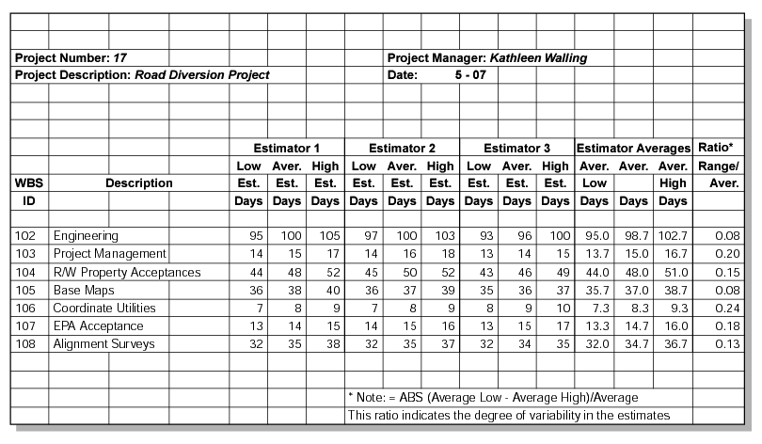
<Example (advanced): effort/cost Estimation sheet and analysis with multiple estimators>
<Don't forget to delete this example from your final Work Plan>
<For the documentation of your effort/cost estimation, you can use any template or representation that accommodates your project's needs and project/organisational requirements. >
<We remind you that you are not obliged to use the templates provided here as examples. You can use your own template or software application (e.g. MS Project) and then simply copy&paste it into this document, or simply reference the relevant file (offer a link or a folder/file location).>

Resource needs
<In this section a list of the necessary project resources can be added. In particular, a distinction shall be made between human and non-human resources. This was previously in the Resource Plan.>
< As an example, a project may need the following type of resources:
- People
- Software
- Hardware
- Equipment
- Buildings & Facilities
- Supplies
- Materials
- Other…>

Resource Plan
<Include both human and non-human resources>
Human Resources
Resource ID | From Date | To  Date | Resource | Skill | Skill Level | Quantity
H.1 | 10/01/13 | 20/08/13 | Consultant | Security | Advanced | 2
H.2 | 10/05/13 | 20/09/13 | Legal Advisor | Policy | Intermediate | 1
H.3 | 10/05/13 | 20/06/13 | Trainer | PM² | Experienced | 2

Other Resources
Resource ID | From Date | To  Date | Resource | Characteristics | Quantity
M.1 | 10/01/13 | 20/08/13 | Licenses | Dedicated | 100
M.2 | 02/05/13 | 22/09/13 | Laptop | Office 2010 | 3
M.3 | 02/05/13 | 22/09/13 | Training Room | 30 seats | 1

<Resource ID – unique resource ID to identify the resource (people or other)
Date (from/to) – identifies the dates that the resource (people or other) are needed for the project
Resource – identifies the resource roles (people or material) that is concerned
Skill – identifies the skills that this resource must have
Skill level – identifies the required skill level in order to guarantee the quality of the project deliverables
Characteristics – any characteristics that this resource must have
Quantity – identifies the quantity of the resources needed (e.g. number of resources).>

Cost of Resources <Note that this is only another view of costs defined in section 3.1>
All Resources
Resource ID | Resource | Cost per unit | No. of units | Total cost
H.1 | Consultant | 500€ per md | 40 md | € 20.000
H.2 | Legal Advisor | 400€ per md | 20 md | € 8.000
M.1 | Licenses | 800€ per connection | 100 connections | € 80.000
H.3 | Trainer | 500€ per md | 10 md | € 5.000
<Cost per unit – identifies the cost per resource unit for the specific resource
No. of units – identifies the number of units needed for the specific resource (man-days, connections)
Total cost – identifies the cost for the specific resource.>

Resource Availability
<Document any known availability constraints of critical resources.>
Resource ID | Resource | Unavailable  from | Unavailable  To | Reason
H.1 | Consultant | 01/07/13 | 01/08/2013 | vacation
H.2 | Legal Advisor | 15/07/13 | 25/07/2013 | training
M.3 | Training Room | 1/07/13 | 15/07/13 | renovations
<Unavailable (from/to) – identifies the dates that the staff is unavailable for the project
Reason – identifies the reason of unavailability.>
<Document any known capacity constraints of critical resources.>

Resource ID | Resource | Availability | Comments
H.1 | Consultant | 100% | Full time external intramuros
H.2 | Legal Advisor | 50% | Work on Project xyz
<Availability – identifies the status of the resources (if they are fully assigned in the project or shared).
Contingencies
Resource ID | Resource | Contingency | Comments
H.1 | Consultant | 5 md | To account for implementation risks.
H.2 | Legal Advisor | 5 md | In case there are delays in receiving a response from Agency xyz.
M.1 | Licence | 10 units | To ensure we never run out of licenses for testing.
<Contingency – identifies the buffer (time or units) that must be considered>

Project Schedule
This section documents the dependencies between tasks, resource assignments for each task, task start and end dates and the overall project schedule and duration.
<Different scheduling methods and representations can be used. For instance, a list of dates/deadlines, milestone plans, bar charts, network diagrams and linked bar charts can be used, and very often can be seen as complementary to each other. Note that the effectiveness of each scheduling method (or combination) depends on the type, size, complexity and dynamics, and documentation and control requirements of each project.>
Work Breakdown |  |  |  |  | Predecessors /  Dependencies | Resource | Quantity | Cost | Start  Date | End  Date
1.0 |  | Project |  |  | -
1.1 |  | Deliverable
1.1.1 |  |  | Activity
1.1.1.1 |  |  |  | Task
1.1.1.2 |  |  |  | Task
1.1.2 |  |  | Activity
1.1.3 |  |  | Activity
1.2 |  | Deliverable
1.2.1 |  |  | Activity
1.2.2 |  |  | Activity
1.2.3 |  |  | Activity
1.3 |  | Deliverable
1.3.1 |  |  | Activity
1.3.2 |  |  | Activity
1.3.2.1 |  |  |  | Task
1.3.2.2 |  |  |  | Task
1.3.3 |  |  | Activity
<Template for documenting project scheduling information>
<Example: Bar chart (schedule representation)>
<Don't forget to delete this example from your final Work Plan>
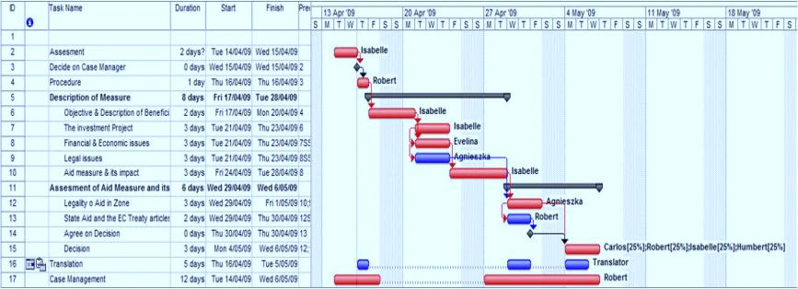<Example: Gantt representation of project schedule >
<Don't forget to delete this example from your final Work Plan>
<For the documentation of your effort/cost estimation, you can use any template or representation that accommodates your project's needs and project/organisational requirements. >
<For smaller projects, a high level description of the project schedule as a milestones plan may be adequate. For other cases, a more complete "Gantt chart" representation of the schedule may be useful.>
<We remind you that you are not obliged to use the templates provided here as examples. You can use your own template or software application (e.g. MS Project) and then simply copy&paste it into this document, or simply reference the relevant file (offer a link or a folder/file location).>

Related PM² Plans
Project Handbook
The Project Handbook establishes the high-level approach for implementing the project goals, which includes required documentation, standards to be considered and the high level summary of the quality and configuration management approach. The location of this artefact is found in the Appendix 1.
Other Related Plans
- Communications Management Plan
- Quality Management Plan
- Transition Plan
- Business Implementation Plan
- Requirements Management Plan
- Deliverables Acceptance Plan
<Complete the above list as required.>

Appendix 1: References and Related Documents
<Use this section to reference (or append if needed in a separate annex) any relevant or additional information. Specify each reference or related document by title, version (if applicable), date, and source (e.g. the location of the document or the publishing organisation).>
ID | Reference or Related Document | Source or Link/Location
1 | <Example of a related document>  04.Project_Handbook.XYZ.11-11-2013.V.1.0.docx | <Example of a location>  < U:\METHODS\PM²@EC\Documents\>
2 | 08.Quality_Management_Plan.XYZ.11-11-2013.V.1.0.docx | <Insert project artefact location.>
3 | 09.Communications_Management_Plan.XYZ.11-11-2013.V.1.0.docx | <Insert project artefact location.>
4 | 10.Deliverables_Acceptance_Management_Plan.V.1.0.docx | <Insert project artefact location.>
5 | XX.Deliverables_Acceptance_Note.XYZ.11-11-2013.V.1.0.docx | <Insert project artefact location.>
6 | Project folder | <Insert project folder location.>
7 | <Example of a reference>  <"The Communication on Risk Management, SEC(2005)1327"> | <Example of a source>  <20/10/2005, European Commission>
8

